Beomjin Han
Dr. Mitchell
CSC 148
HW3

1.
Del Taco
2200 Arden Way, Sacramento, CA 95825
Sample collected on 10/19/2019.
This establishment is a medium-sized mexican fast food restaurant with a drive-thru.

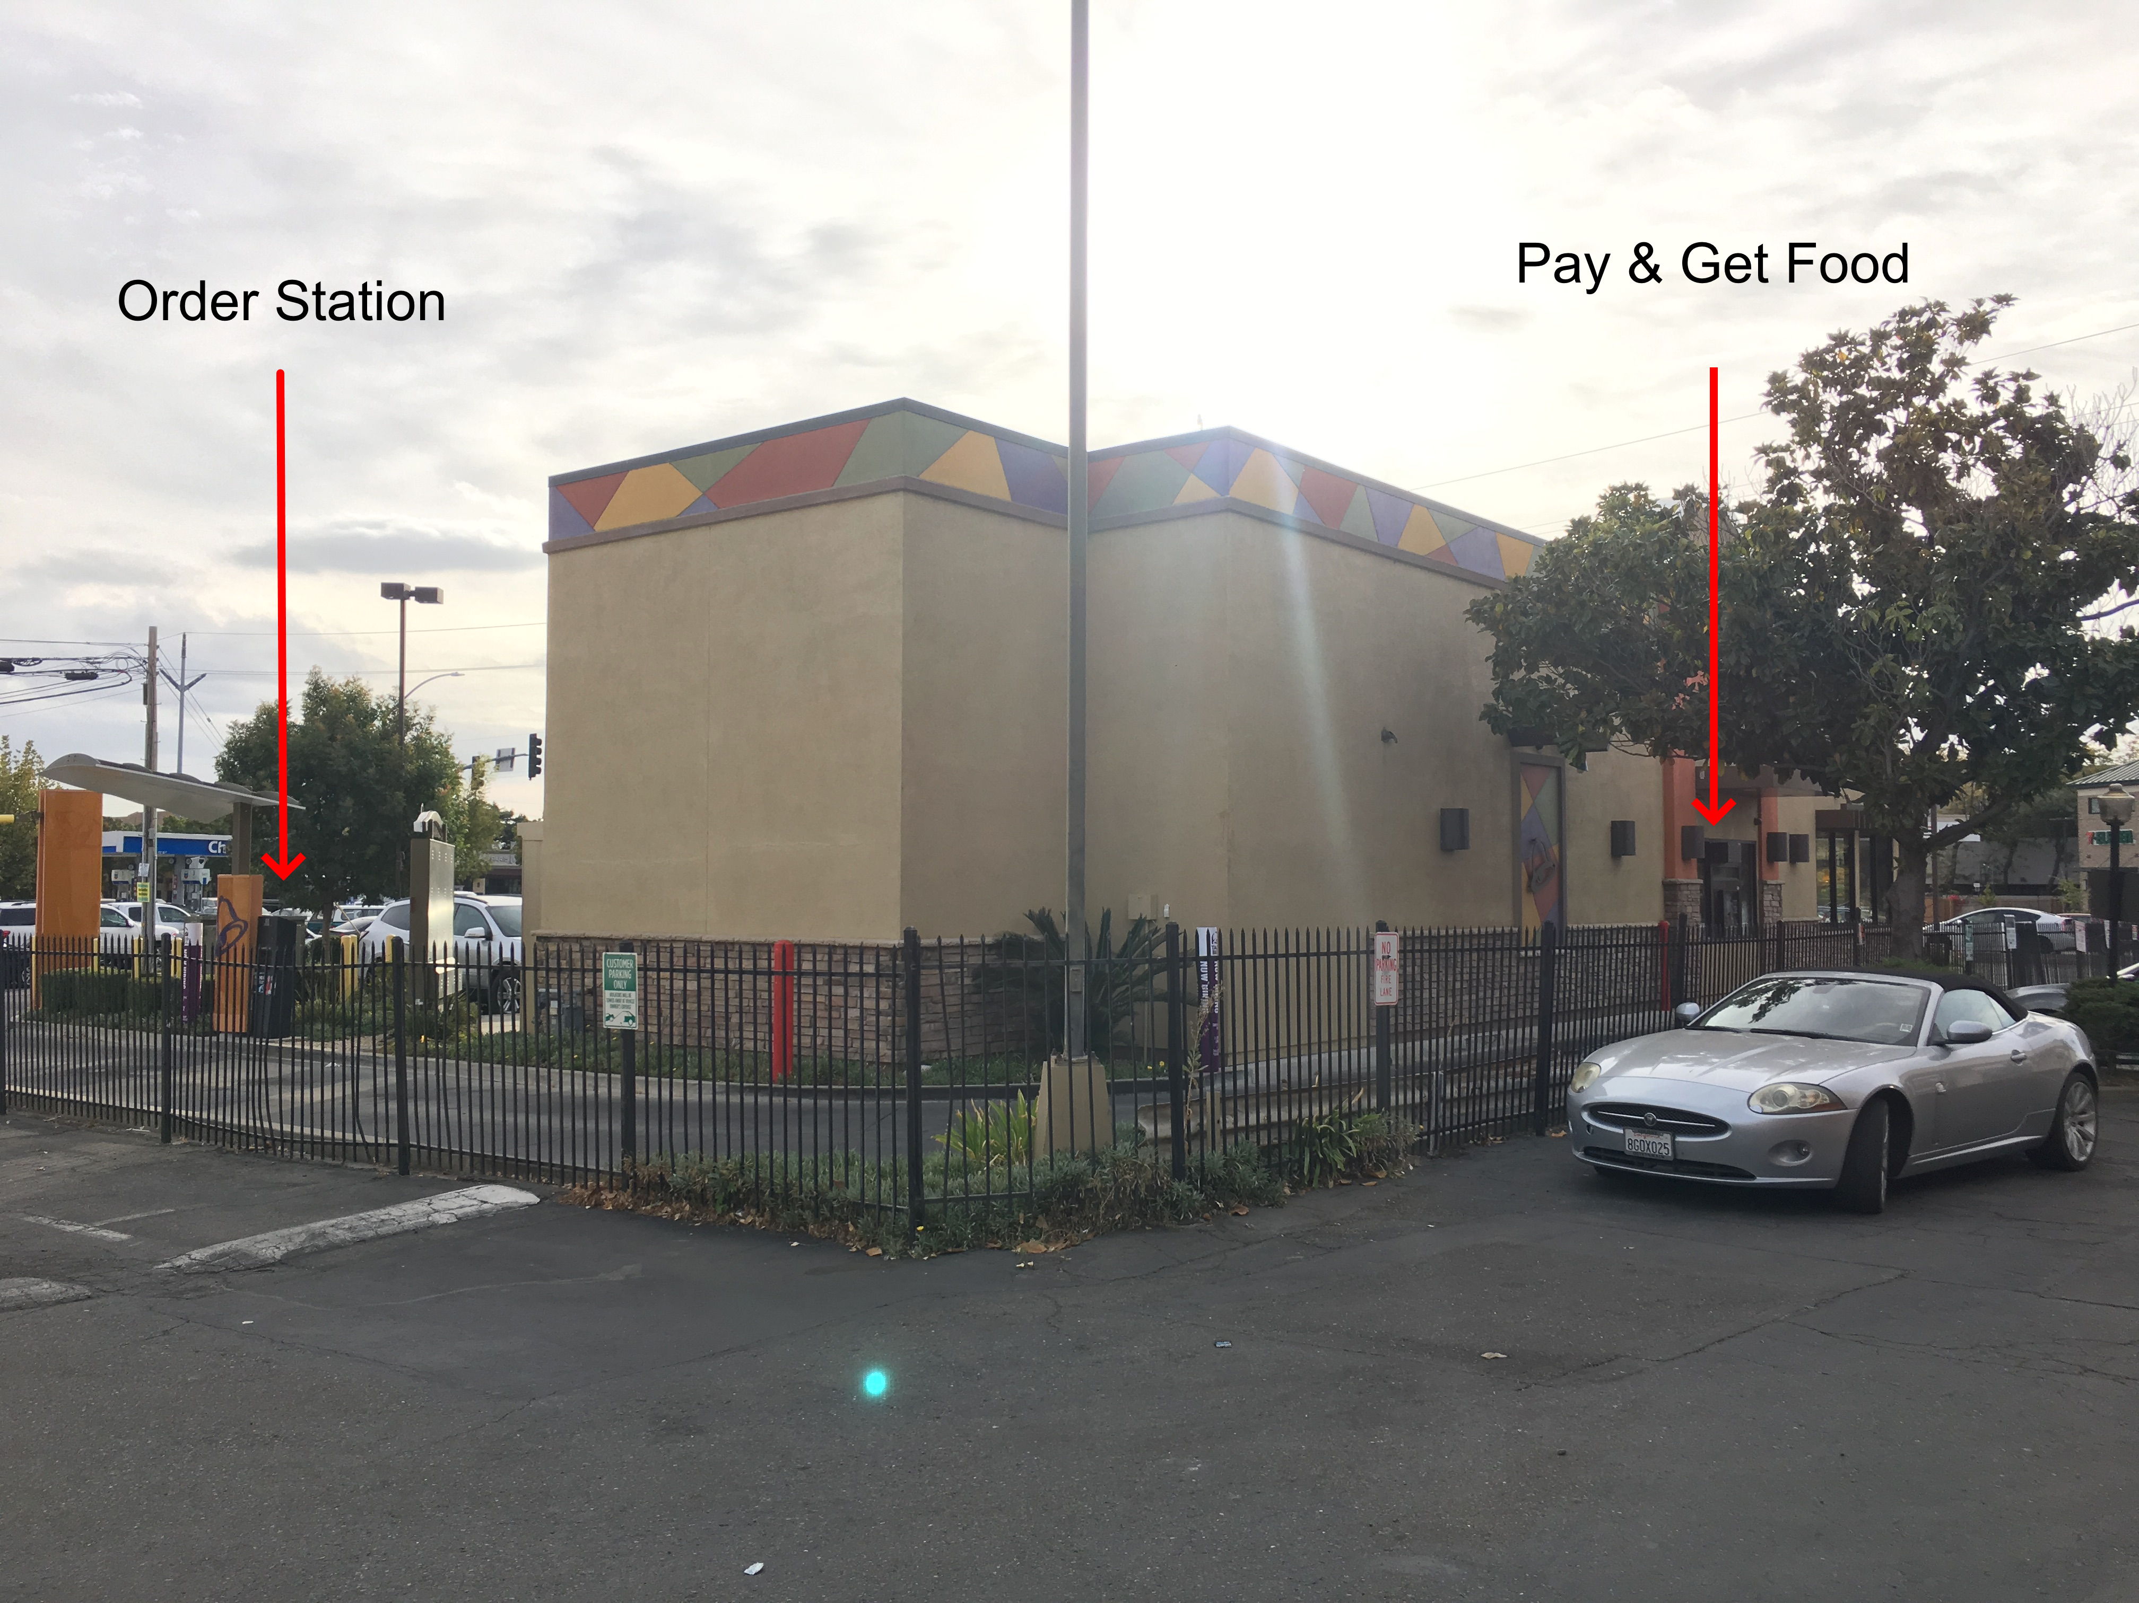
The number of service centers nSteps = 2 because O is done at one step, and P & G at the same station.

3.
sis = 4 minutes
216 minutes / 4 minutes = 54 sis intervals
100 Cj arrivals / 54 sis intervals = 1.85 arrivals/interval (sample mean x^)
1.85 arrivals/interval / 240 seconds/interval = 0.0077 customers/sec

4.
Little's Law check
A stable system satisfies L = λ * w
L^ = avg(the value of L as each c arrives)/(total number of c)
=(208/100) = 2.08
λ ^= (number of c that arrived)/(observation duration)
= 100 customers / 12983 seconds = 0.0077 customers/sec
w^ = (total time spent in S by all c)/(total number of c)
= 29575 seconds / 100 = 295.75
λ ^* w^ = 2.278

L^/(λ^*w^) = 0.913

